Admin for Components

Definition: each component can have a single or multiple administrators.
Set Admin Variables
1 – Each user has a field assigned to components (AdminComponents).
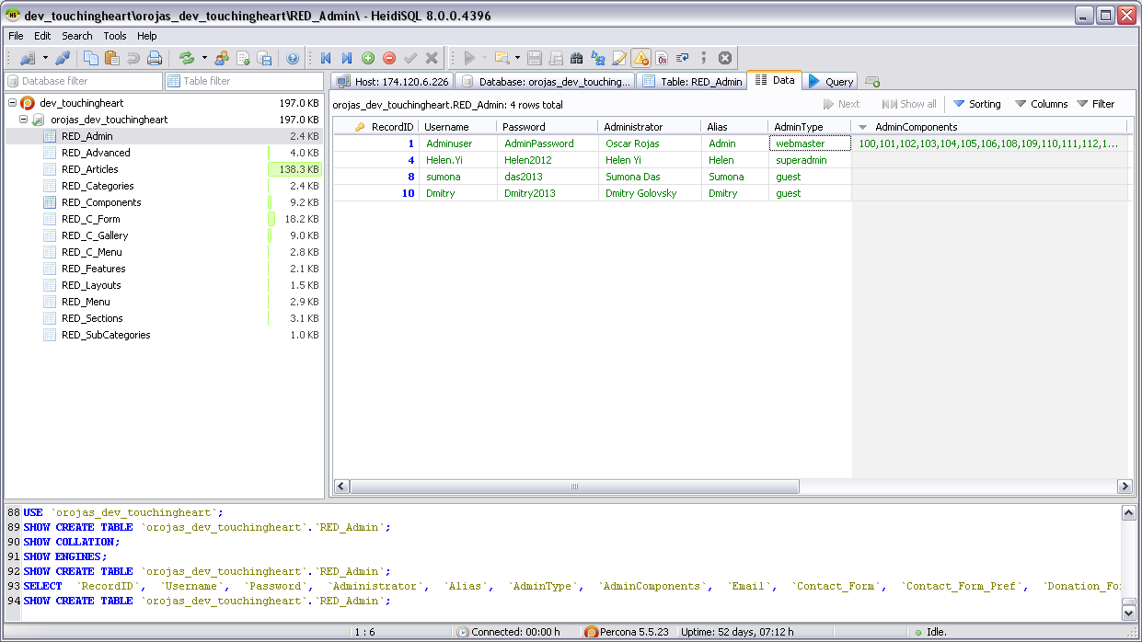
2 – In AdminComponents enter the RecordID of the components the user has permissions to add or edit. Note that for components which have different layouts you must enter all range of RecordID. For example form range goes from 102 – 105. Important: If you add only one of those numbers to the AdminComponents field, then that user will have access to edit any form. In the other hand, that user will only have permission to add that single layout.
